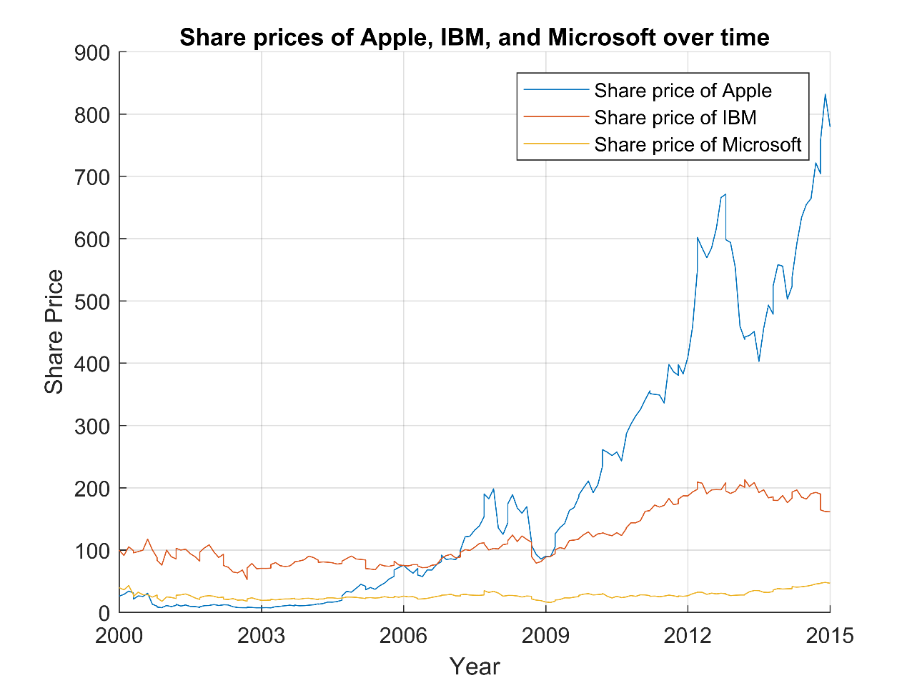

Figure 1: Plot of Share prices of Apple, IBM and Microsoft from 2000 to 2015. The share price of Apple has had a meteoric rise starting from 2005, greatly surpassing the share prices of IBM and Microsoft. Both IBM and Microsoft have had slower growth than Apple, although Microsoft seems to be stepping up since 2013 but IBM seems to be slowing down and has been experiencing a decreasing share price since 2013.